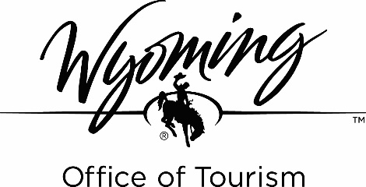
Title: Part-Time Welcome Center Specialist
Location: Cheyenne
Division: Business Operations
Reports To: Visitor Services Supervisor
Position Status: Non-Exempt
Salary: $14.00 hour
Date: March 1, 2023

The Wyoming Office of Tourism is the only statewide Destination Marketing Organization (DMO) dedicated to growing Wyoming’s tourism economy.

Purpose: The Part-time Welcome Center Specialist provides excellent customer service to Wyoming Welcome Center visitors by delivering up-to-date information and promoting Wyoming sites, attractions, events, and points of interest to enhance customer’s experience and influence a longer stay in the state.

Essential Duties:.
- Engages in excellent customer service by greeting and communicating directly with visitors to make them feel welcome and answer their questions.
- Utilizes research skills to seek out information in response to questions and guide visitors to Wyoming sites, attractions, events, and points of interest based on their preferences.
- Sustains relationships with area businesses and partners by promoting special events and other points of interest to visitors.
- Upholds attention to detail to maintain appearance of the Welcome Center through routine cleaning and addressing minor problems that may occur.
- Maintain stocking of brochure displays, office space and warehouse.
- Practices good communication skills by responding to inquiries via email and over the phone.

Position Requirements:
- Problem Solver: Resourceful in finding information and understanding needs.
- Informed: Knowledge of Wyoming history, geography, motor vehicle laws, tourist attractions, sites and recreational opportunities including local, statewide, and regional events. Familiar with major highways and throughways.
- People Person: Engages well with customers and aware of yourself and others. Displays appropriate interpersonal skills including active listening, flexibility, patience, etc.
- Professional Effectiveness: Strong communication skills; written and oral, Ability to be flexible, work independently and as a member of the team.
- Basic computer knowledge including Microsoft, Google docs and internet search capabilities.
- Must be able to work weekends and holidays.
- Ability to lift 30+ pounds.
- Work well both independently and as a member of a team.
- Prefer education and/or training equivalent to a high school diploma and one year of customer service or public relations experience.

